|  |
| --- |
| HOCKEY ALBERTA  PROVINCIAL CHAMPIONSHIPS  BID GUIDELINES |

Table of Contents

**1.0 INTRODUCTION AND INFORMATION**

**2.0 BID APPLICATION PROCESS AND SITE SELECTION**

**3.0 SITE SELECTION CONSIDERATIONS**

A) Community Overview

B) HOST COMMITTEE

C) Business Plan

1. Marketing / Advertising / Revenue Generation
2. Ticketing
3. Legacy Plan

D) Operational Plan

1. Arena / Facilities

1. Hotel Accommodations
2. Transportation
3. Website & E-Game Sheets
4. Accreditation and Security
5. Community / Special Events
6. Food Services
7. Team Services
8. Medical / Emergency Services
9. Volunteers
10. Insurance
11. Souvenirs / Merchandise / Awards

**4.0 SCHOOLS PROGRAM**

**APPENDICES**

#### Appendix A: AeHL & AFHL hosting informaTIon

#### Appendix b: Sample Budget SHEET

#### Appendix c: Hockey Alberta Referee Rates

Appendix d: Schedules

Appendix E: Arena Safety Checklist

Appendix F: Bid Guidelines Checklist

Appendix G: Host Application Form

**1.0 INTRODUCTION AND INFORMATION**

**GENERAL**

The Hockey Alberta Provincial Championships are some of the most exciting and high-profile events in which Hockey Alberta’s membership takes part each season, bringing together the top teams from across the province in each category. The thrill of playing in this exciting event makes hosting a Hockey Alberta Provincial Championship tournament a unique and special opportunity.

This Bid Guidelines document outlines the requirements involved, and the opportunities available, for a Minor Hockey Association (MHA) interested in submitting a bid to host a Hockey Alberta Provincial Championship event.

If hosting a Provincial Championship is something your community is interested in, please review this document thoroughly. A bid application that addresses all details provides you with a better opportunity to be selected if your chosen event has multiple applicants. The format and layout of the application is up to the individual applicant.

**PROVINCIAL CHAMPIONSHIP DATES**

March 20-23: U18 Female A; U18 Female B;

U16 AA

U15 AAA; U15 AA; U15 A, B, C, U15 A NBC;

U15 Female AA;

U13 A, B, C, D; U13 Female A; U13 Female B.

March 27-30: U18 AA; U18 A, B, C, U18 A NBC;

U18 Female AA;

U15 Female A; U15 Female B;

U13 AA, U13 Female AA;

U11 AA

April 3-6: U17 AAA

*See Appendix A for AEHL & AFHL category specific hosting requirements

**NOTES**

Hockey Alberta sanctions, and is responsible for overseeing, each Provincial Championship event. The Host Committee for each event will be required to work with, and provide regular reports to, Hockey Alberta on the progress of their event. Some aspects of the tournament planning will require the approval/permission of Hockey Alberta.

The team of the host MHA for a Provincial Championship receives automatic entry into the championship. However, the team must participate in its respective League playdowns, as the team can earn a League title.

If you have questions, contact Hockey Alberta: email [provincials@hockeyalberta.ca](mailto:provincials@hockeyalberta.ca) or phone 403-342-6777.

Thank you for your interest in hosting and good luck!

**2.0 BID APPLICATION PROCESS AND SITE SELECTION**

These Bid Guidelines have been developed to facilitate the selection of the host sites for the Hockey Alberta Provincial Championships. Hockey Alberta reserves the right to make changes to the bid criteria as may be deemed necessary and to request additional information from the potential host sites concerning any aspect of the application.

**Timelines & Process**

**STEP 1: November 15 – Deadline for MHAs to submit bids**

All Bid Applications MUST be submitted to the Hockey Alberta office by this deadline. ***Bids must be submitted via email in PDF format to*** [***provincials@hockeyalberta.ca***](mailto:provincials@hockeyalberta.ca)

**STEP 2: November 15 – 30 – Review of Bids**

A selection committee will undertake its review of all bids and request additional information or answers to follow up questions at any point in time to assist with the review of bids. The Selection Committee reserves the right to conduct site visits to confirm details laid out in a bid, or to confirm technical requirements as outlined in the bid conform to what is required.

**STEP 3: December 1 – Selection and Notification**

In submitting their applications to host, the bid applicants have acknowledged that the decision to award the hosting of the Provincial Championships rests solely with Hockey Alberta through the Selection Committee. The Hockey Alberta selection committee will make its decisions and will forward a copy of the Provincial Championship Hosting Manual and Agreement to the selected MHAs prior to **December 15.** A signed copy will be due back from each selected host group prior to any public announcement being made.

**STEP 4: December 15 – Announcement of Host Sites**

Upon receiving a signed copy of the Hosting Agreement, Hockey Alberta will announce the selected Provincial Championship Host Sites to the public. It is the responsibility of the Host Committee, host MHA, and any other bid partners to begin fulfilling the obligations of the bid guidelines as well as the commitments laid out in the winning bid immediately upon being awarded the Provincial Championship.

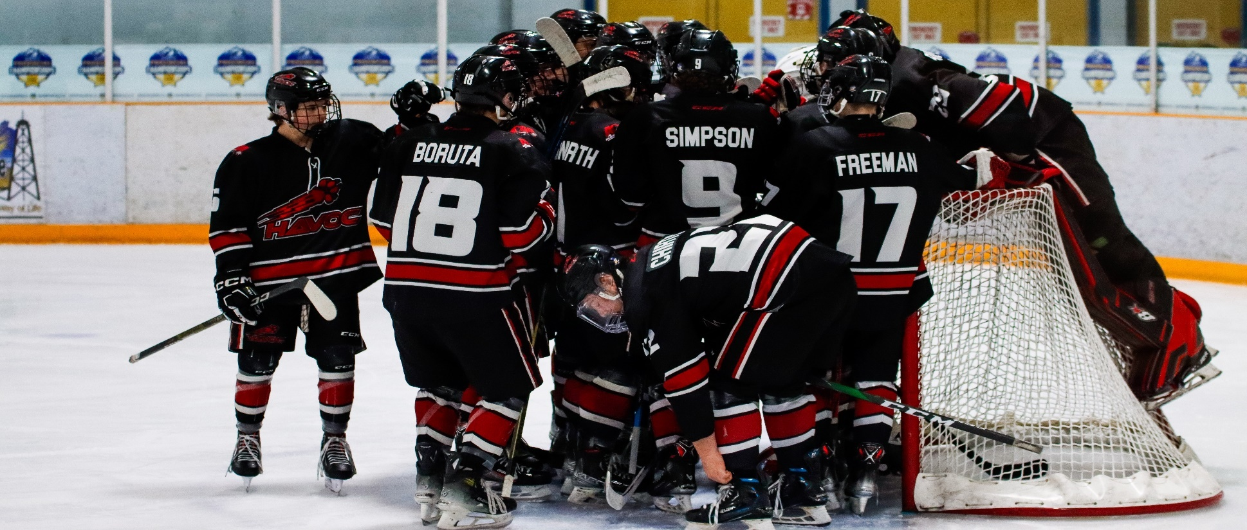

**3.0 SITE SELECTION CONSIDERATIONS**

The bid presentation should contain certain components to allow the selection committee to make a detailed evaluation of the bid submissions. This section will provide some additional detail in terms of responsibilities and expectations in those areas.

For a community to be considered as a potential Provincial Championship host, the following minimum hosting standards must be met:

* Be a Hockey Alberta Member MHA in good standing.
* Have a strong volunteer base within the hockey and business communities.
* Have an arena facility, suitable for the respective division/category of hockey, to serve as the main site for all games.
* Have reasonable accommodations available within proximity.

**A) Community Overview**

The bid application should contain an overview of the hosting community and region, as well as any other characteristics which may enhance the bid.

* Rationale supporting the bid by highlighting the characteristics of the communities and surrounding areas that will be utilized in the event.
* Map of the host community indicating locations of key facilities (i.e. arena, hotels, ancillary venues) with detailed listing of distances and travel times.

**B) Host Committee**

Bids should include an introduction to key personnel on the Host Committee and their roles. This can be laid out in the form of an organization chart. The Host Committee should be comprised of representatives from the local business community, local hockey program(s) and Hockey Alberta’s member MHA. As part of the bid application, the Host Committee will need to:

* Assume financial responsibility for the event;
* Appoint the following Committee Chairpersons, but not limited to:
* Operations
* Marketing/Media
* Website
* Special Events/Protocol Accreditation
* Facilities
* Include information on event goals and ways to track and measure the success of the event.

**C) Business Plan**

The bid application should include a comprehensive Business Plan which will serve as the primary guide for the organization and the financial operation of the event. The Business Plan should tie together a ticketing plan, sponsorship plan, and budget, along with the marketing/advertising plan.

The Business Plan should include the following information:

* Key financial objectives, including breakeven and targeted goals.
* Financial forecast reflecting all potential revenues and all potential expenditures related with staging the event. Include information to support the numbers and how you plan to reach your targets.
* Ticketing plan and strategy detailing every phase of ticket sales, price points, timelines and targets.
* Sponsorship plan and strategy detailing levels of sponsorship, prospect list, timelines, and goals. Sponsorship plan needs to recognize Hockey Alberta’s sponsorship guidelines and exclusivities as well as detailing any in-kind partners who may be able to assist your event.
* Detailed Critical path on all key tasks the Host Committee will be attempting to accomplish in hosting the Provincial Championship.

The net proceeds or losses of the event will be the responsibility of the Host Committee and/or the MHA. Hockey Alberta asks that the Host Committee have a legacy plan to deal with potential surplus and that it is outlined in the bid presentation. Please refer to **Appendix B** for a sample budget.

The Host Committee’s obligations for event expenses should include, but are not limited to the following items:

* Arena facilities;
* Necessary staffing and off-ice officials (time-keeper, online score-keeper, penalty box operators);
* Announcer and In Game Music Coordinator;
* Marketing and promotional expenses (newspaper, television, radio station, etc);
* Tournament Program: All expenses associated with producing the official tournament program for the event. Hockey Alberta will provide four (4) pages of content for the program (front and back covers, and inside cover pages) in digital format. Hosts will have the option to print their program or create a digital version and will be responsible for finding a printer and covering all costs related to printing, including the pages provided by Hockey Alberta.
* Various event administration expenses, including meetings, postage, etc.;
* Tickets, security and VIP accreditation (Hockey Alberta will provide passes that can be used for sponsors, volunteers, players, team officials, Officials and Host Committee members);
* Officials’ game fees and travel (if required);
* Accommodations and meals for one (1) Hockey Alberta Representative and one (1) Officials Supervisor;
* Optional, but can add to the event experience:
  + Tournament banquet/ luncheon/ breakfast
  + Awards (player of the game/ heart and hustle)
  + Hospitality room
  + Opening/closing ceremonies;
  + League/ Representative/ Host Banners

1. **Marketing / Advertising / Revenue Generation**

Each host is required to have a Marketing/Advertising plan that incorporates earned and bought media from day one until the Provincial Championship is over. This plan should detail the advertising/media plan, including promotion of sponsorship and ticket sales plans.

Venue Sales - plans should indicate the level of sales which can be achieved at the arena venue in merchandise, raffles and souvenir programs;

Local/Regional Sponsorship – plans should outline the market potential for cash and contra (product) sponsorships;

Municipal support/ Granting – if available should be noted, including major financial contributions for hosting events;

Other contributions such as in-kind donations and services should also be included in the bid.

Revenue Generation – Hosts are able, and encouraged, to operate 50/50s and/or raffles in-venue and within the community (making sure to follow AGLC guidelines). Hockey Alberta may choose to operate an online Province wide 50/50 throughout the duration of Provincials and if so, Hockey Alberta Members may be asked to promote the Provincial raffle in exchange for a portion of the profit. More details will be confirmed with successful Hosts throughout the planning process.

1. **Tickets**

Plans should outline the strategy for the pricing and packaging of ticket sales for the event. The Host **Committee cannot charge a team entry fee for this tournament,** however the Host Committee may charge gate admission for this tournament. Please refer below for pricing options for successful Host Sites.

Ticket Admission/Gate Prices Suggestion Maximum

1) ADULT EVENT PASS $15-$20 $25

2) ADULT DAY PASS $7-$10 $15

3) SENIOR/ STUDENT EVENT PASS $10-$15 $20

4) SENIOR/ STUDENT DAY PASS $5-$7 $10

5) FAMILY (2 ADULTS/2 YOUTH) WEEKEND PASS $40-$60 $65

The Host Committee **cannot** charge a team entry fee for any of the events.

1. **Legacy Plan**

The host committee will need to provide specific detail on how the local portion of the financial legacy will be directed after the event is completed. The plan will be used to provide direction and show the site selection committee where bid groups see their legacy being directed back into hockey. A sample legacy plan template can be found in APPENDIX H.

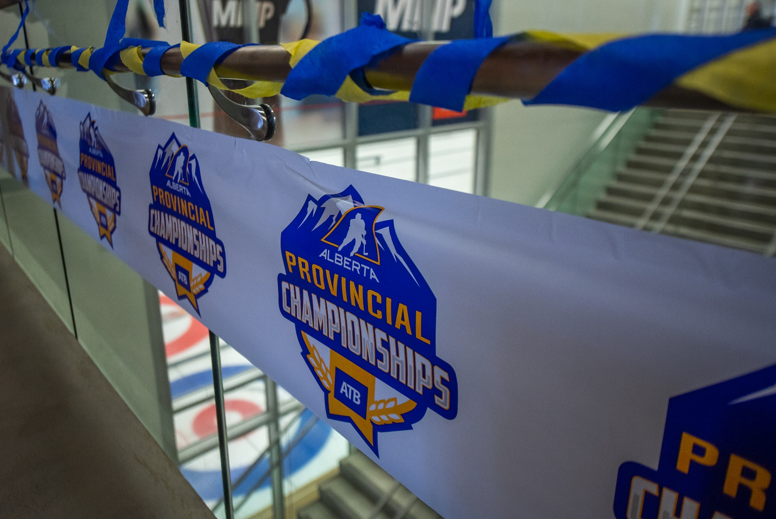

**D) Operational Plan**

1. **Arena / Facilities**

To host an event of this type, certain facility standards must be met, including:

* The host arena must be available on an exclusive basis to the Host Committee for the duration of the event and ice should be booked in accordance with the schedules included in APPENDIX D
* Host arena must be located within the host city/town;
* The main host arena must have adequate seating space;
* A minimum of four (4) dressing rooms, one (1) officials room, and one (1) alternate change room are required for this event;
* An office area designated for the duration of the tournament to be used for the coaches/managers meeting and all discipline and complaint hearings;
* Foyer/display area for merchandising, draw boards (schedule), and sponsor requirements as applicable.

1. **Hotel Accommodations**

The Host Committee will be responsible to show that the following hotel requirements are available in or near the host site. Ensure **written confirmation from the hotel(s)**, that a minimum of:

* + 50 hotel rooms for 4 team event
  + 75 hotel rooms for 5 team event
  + 100 hotel rooms for 6 team event
  + 120 hotel rooms for 8 team event

are available to house the participating teams within a thirty (30) to forty-five (45) minute drive from the host arena. **(Accommodations must meet a quality standard, which will be reviewed by the bid selection committee.)**

Teams are not required to stay in the hotel(s) that are suggested by the Host Committee as Teams will be responsible for booking and paying for their own accommodation and meal expenses;

Ensure a plan is in place to budget & accommodate the Hockey Alberta Representative & Officials Supervisor, if needed. As well, any potential out of town officials that may need accommodations for the duration of the tournament. These costs are the responsibility of the Host and should be factored into the budget plan.

1. **Transportation**

The cost associated with all travel related to the tournament, meals and accommodations at the event are the sole responsibility of each participating team. The Host Committee is **not** responsible for any transportation costs of any type for the participating teams.

The costs associated with travel of any out-of-town game officials are the responsibility of the Host and should be factored into the budget plan.

1. **Website & E-Game Sheets**

Provincial Championships’ website (provided by Hockey Alberta) MUST be utilized by the host committee for live scoring of each game during the event. No paper game sheets are provided. AEHL and AFHL events use their regular FloHockey/ LeagueStat websites. All other events use the RAMP Provincial Championships platform, with login credentials provided to each host after attending the mandatory scorekeeper/ website training session in February.

Each host should ensure a minimum of two (2) volunteers are trained on the website platform. Hosts can also utilize the event website to post news and updates for participants, fans and the media leading up to and during the event.

1. **Accreditation / Information / Security**

Hockey Alberta provides standardized blank name tags to all host committees. It is recommended they are to be used for all athletes, team officials, game officials, Host Committee and volunteers. The amount that will be provided will be determined once the host has been identified, depending on the number of teams that will be participating.

The Host Committee will be responsible to provide the following:

* An information package for participating teams, on-ice officials, media, VIPs and other dignitaries. This can be digital format.
* Establishing a system to ensure all participating teams and visiting VIPs are provided with adequate identification and security.
* VIP Passes / Game Tickets (if applicable)
* Reserve complimentary entrance to the event for all identified local sponsor(s) and media.

1. **Community / Special Events**

The Host Committee will be responsible to coordinate all protocol arrangements for the event ensuring activities such as opening and closing ceremonies, special receptions and hospitality arrangements are conducted in accordance with Hockey Alberta guidelines.

Upon request, provide up to 5 tickets to Hockey Alberta for any special event functions held.

The Host Committee is encouraged to expand the event into the community with the staging of both on and off-ice special events to create a unique atmosphere for your community, athletes and fans. The plan for special events should be outlined in general terms during the bid presentation.

Some event ideas include:

* Puck toss between periods/ Intermission shows;
* Special draws for those in attendance or program purchasers;
* Festival or Carnival – with face painting, games, mini stick hockey etc.
* “Farmers or Crafters Market” – including a bake and craft sale etc.

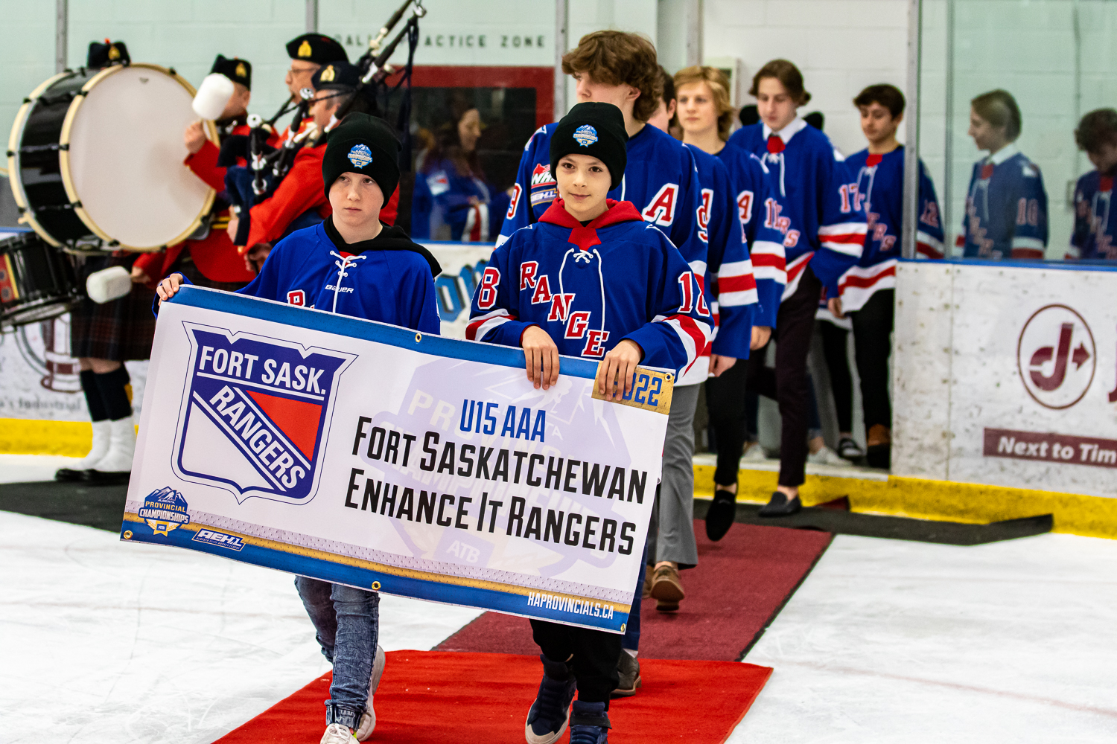

1. **Food Services**

The Host Committee is responsible for providing meals for one (1) assigned Hockey Alberta Rep and one (1) Officials Supervisor throughout the duration of the tournament.

Participating Teams and On-Ice Officials are responsible for their own meals and there is no requirement for a Host Committee to provide or reimburse them for meals.

1. **Team Services**

The Host Committee is required to provide participating teams with the following team service elements:

* Information about laundry service for teams to have their team laundry done, at their own cost. This will include jerseys, socks, and player undergarments;
* Information about equipment repair services (on call) for all teams in the case of an emergency;
* Industrial fans, dehumidifiers, and heaters where necessary to assist in drying of team equipment between games;
* Access to drinkable water in venue;
* A list of other qualified medical professionals that can be made available (on call) for the teams during the tournament. Dentist, Chiropractor, Physio, Massage, etc.

1. **Medical / Emergency Services**

It is mandatory that the Host Committee provide a Risk Management/ Safety plan to deal with issues/ emergencies as they arise and provide medically responsible personnel available or on site for every game (i.e. St. John Ambulance), if possible.

1. **Volunteers**

To stage an event of this magnitude, the Host Committee will be required to recruit, train, support and direct the efforts of numerous community volunteers.

In consideration of this critical group, the bid documents must include:

* Volunteer program and plan for training, coordination, screening, recruitment and recognition.
* All volunteers and committee members should undergo a criminal record/background check, especially those working near the players or with money.

1. **Insurance**

Hockey Canada will supply the liability insurance for the duration of the event for the Host Committee. A Certificate is available, if required, by your facility.

The Host Committee is responsible to secure event cancellation insurance in the event that the Provincial Championship or any other ancillary events must be cancelled for seen or unforeseen reasons.

It is recommended that the Host Committee obtain content insurance for all Provincial Championship related supplies, awards, materials, and equipment shipped in advance and stored on site.

1. **Souvenirs / Merchandise / Awards**

The Host Committee will be responsible for all aspects of procuring and distributing any souvenirs, merchandise, and/or photographs to be provided free to participants or made available for sale to those attending the Provincial Championship.

Each Host Committee will be provided with electronic files of the official Provincial Championship logo, as well as logo pantones, and other necessary information.

For the safety and integrity of both the host MHA and Provincial Championships, please contact Hockey Alberta if you are unsure of a vendor, their product or reputation.

**If a Host Committee desires to adapt the official Provincial Championship logo to include local information such as Town, Division, and/or Date, a copy of the proposed logo MUST BE submitted FOR APPROVAL to the Marketing department of Hockey Alberta. No other changes to the Provincial Championship logo will be permitted.**

Hockey Alberta will provide the following:

* Championship Banner & Plaque
* Championship Hats
* Gold, Silver and Bronze medals (if applicable)
* Officials gift for those working the Gold Medal game
* Game pucks
* Roll Banners

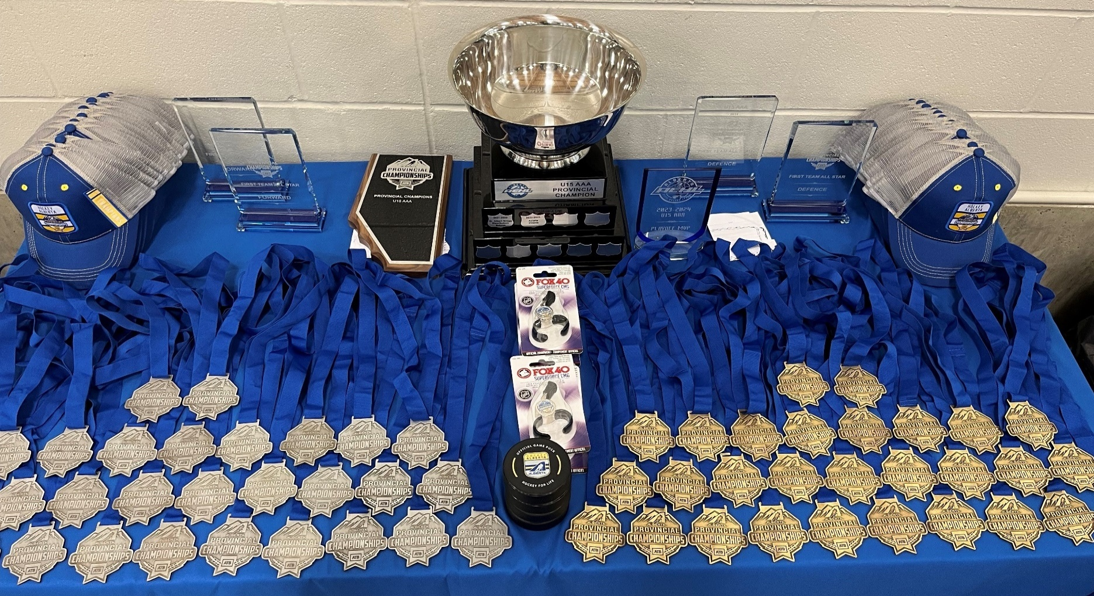

**4.0 SCHOOLS PROGRAM**

The Schools Program is a unique partnership between Hockey Alberta and the Host Committees for Hockey Alberta Provincial Championships with schools in local communities designed to celebrate a shared love for hockey and the community that supports the sport.

The goal is to create excitement around hockey and the festivities of the weekend in local schools. Events held have received overwhelmingly positive feedback from schools, parents, and most importantly the students.

Each Host Committee, in cooperation with a local school in your community, can apply to host an event.

The Schools Program will be held on the Thursday or Friday of the Provincial Championship weekend in each participating community. In conjunction with the Host Committee, each participating school hosts a number of fun activities, allowing students to learn about hockey in the community. Where possible, schools will be encouraged to schedule attendance at the tournament in their community.

**appendix A – AEHL & AFHL HOSTING INFORMATION**

In addition to the information included in the Bid Guidelines, those looking to bid on an AEHL or AFHL Provincial Championship event must consider and provide the following supplemental information with the bid application:

1. **FloHockey**

All provincial championship tournament hosts for AEHL and AFHL divisions (except AEHL U13AA & AFHL U13AA) are required to livestream all games on FloHockey. No other livestreaming platform can be used. Hosts need to make sure the following items are available to livestream:

* Facility broadcasting capabilities
* Equipment on site or available
* Camera operators
* Access to tech support
* Play by Play or color commentators

**Appendix B – Sample Budget SHEET**

Tournament costs can be determined in advance of the scheduled event. Please put some time into your budget planning:

**REVENUE:**

Advertising

Door Admittance

50/50 Draw

Raffles, Silent Auction

Program Sales

Merchandise Sales

Grants

Sponsorship

**TOTAL REVENUE**

## EXPENSE:

Ice

Officials

Medical Services

50/50 Tickets, Fees

Program Printing

Merchandise

Banners/Decorations

Postage

Banquet

Livestreaming

Team Banners

Hockey Alberta Rep/

Officials Supervisor

**TOTAL EXPENSE**

**DIFFERENCE**

*(Revenue less Expense)*

**Appendix C – Hockey Alberta Officials Rates**

**(NOTE: These rates are not to be exceeded.)**

|  |  |  |  |  |
| --- | --- | --- | --- | --- |
| **Category** | **3 Official**  **Game Fee** | **3 Official Split** | **4 Official Game Fee** | **4 Official**  **Split** |
|  |  |  |  |  |
| U18 AAA (AEHL, AFHL) | 216 | 86-65-65 | 292 | 81-81-65-65 |
| U18 AA (Male, AFHL) | 179 | 71-54-54 | 240 | 66-66-54-54 |
| U18, U18 Female | 159 | 63-48-48 | 212 | 58-58-48-48 |
|  |  |  |  |  |
| U17 AAA (AEHL) | 199 | 81-59-59 | 264 | 73-73-59-59 |
|  |  |  |  |  |
| U16 AA | 179 | 71-54-54 | 240 | 66-66-54-54 |
|  |  |  |  |  |
| U15 AAA (AEHL) | 169 | 67-51-51 | 226 | 62-62-51-51 |
| U15 AA (Male, AFHL) | 159 | 63-48-48 | 212 | 58-58-48-48 |
| U15, U15 Female | 146 | 58-44-44 | 196 | 54-54-44-44 |
|  |  |  |  |  |
| U13 AA (Male, AFHL) | 130 | 52-39-39 |  |  |
| U13, U13 Female | 125 | 49-38-38 |  |  |
|  |  |  |  |  |
| U11 | 93 | 39-27-27 |  |  |

***Mileage:*** Mileage for the official travelling the furthest distance (round trip) shall be paid according to Hockey Alberta’s approved rate of $0.41/km.

|  |  |  |  |
| --- | --- | --- | --- |
| **Kilometers Traveled** | **Travel Rate** | **Kilometres Traveled** | **Travel Rate** |
| 0-50 km | $0 | 301-400 km | $40 |
| 51-100 km | $10 | 401-500 km | $50 |
| 101-200 km | $20 | 501-600 km | $60 |
| 201-300 km | $30 | 601-700 km | $70 |

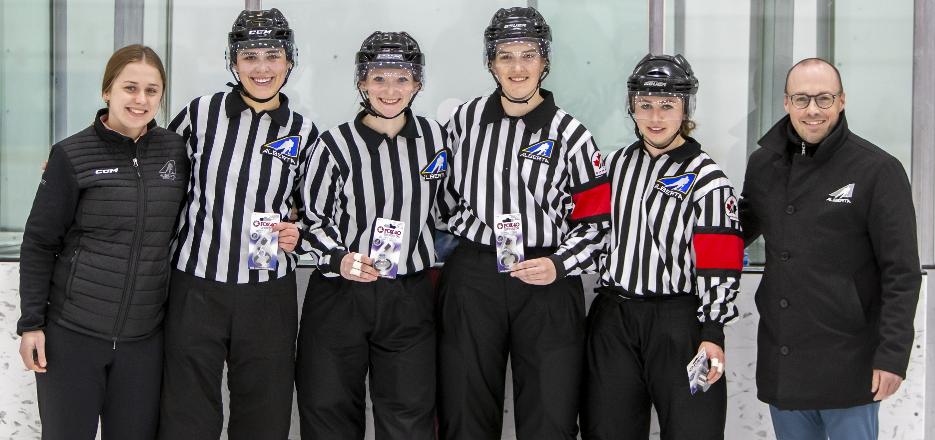

**APPENDIX D – SCHEDULES**

Hockey Alberta, in cooperation with the host committee, will set and approve the official Hockey Alberta Provincial Championship game schedules. Below are the templates for the events, based on the number of ice surfaces reserved. Please note that the layout of the pools and order of games played **will not** be changed or adjusted. Confirmation of the ice booking must be provided in the bid submission for the bid to be accepted.

**8 Team Tournaments**

U18: A, B, C, A NBC, Female A, Female B

U15: A, B, C, A NBC, Female A, Female B

U13: A, B, C, D, Female A, Female B

U11: AA

**5 Team Tournaments**

U18: AA, Female AA

U17: AAA

U16: AA

U15: AAA, AA

U13: AA

***NOTE: It is possible that the number of teams in a tournament may be required to change depending on how many MHAs declare teams for each Category.***

**5 Team Schedule – 1 Arena**

|  |  |  |  |  |  |  |  |  |
| --- | --- | --- | --- | --- | --- | --- | --- | --- |
| **ROUND ROBIN** | | | | | | | | |
| **Game #** | **Day** | **Start** | | **Finish** | | **Home (League)** | **Vs** | **Away (League)** |
|  | **Tuesday** | **8:00** | **PM** | **9:00** | **PM** | **Coaches/Managers Meeting** | | |
|  |  |  |  |  |  |  |  |  |
| 1 | Thursday | 11:00 | AM | 1:30 | PM |  | VS |  |
| 2 | Thursday | 1:45 | PM | 4:15 | PM |  | VS |  |
|  |  | 5:00 | PM | 5:45 | PM | OPENING CEREMONIES | | |
| 3 | Thursday | 6:00 | PM | 8:30 | PM |  | VS |  |
|  |  |  |  |  |  |  |  |  |
| 4 | Friday | 9:00 | AM | 11:30 | AM |  | VS |  |
| 5 | Friday | 11:45 | AM | 2:15 | PM |  | VS |  |
| 6 | Friday | 2:30 | PM | 5:00 | PM |  | VS |  |
| 7 | Friday | 5:15 | PM | 7:45 | PM |  | VS |  |
|  |  |  |  |  |  |  |  |  |
| 8 | Saturday | 10:00 | AM | 12:30 | PM |  | VS |  |
| 9 | Saturday | 12:45 | PM | 3:15 | PM |  | VS |  |
| 10 | Saturday | 4:30 | PM | 7:00 | PM |  | VS |  |
|  |  |  |  |  |  |  |  |  |
| **Game #** | **Day** | **Start** | | **Finish** | | **Home (Zone)** | **Vs** | **Away (Zone)** |
| **BRONZE MEDAL** | | | | | | | | |
| 11 | Sunday | 10:00 | AM | 12:30 | PM | 3rd Place | VS | 4th Place |
| **CHAMPIONSHIP FINAL** | | | | | | | | |
| 12 | Sunday | 1:00 | PM | 4:00 | PM | 1st Place | VS | 2nd Place |

***\*\*Option to move the 4th game on the Friday to Thursday OR the 7th game on the Friday to the Saturday should the host wish to have a banquet or skills competition on the Friday night.***

**8 Team Schedule – 1 Arena**

|  |  |  |  |  |  |  |  |  |
| --- | --- | --- | --- | --- | --- | --- | --- | --- |
| **ROUND ROBIN** | | | | | | | | |
| **Game #** | **Day** | **Start** | | **Finish** | | **Home (League)** | **Vs** | **Away (League)** |
|  | **Tuesday** | **7:00** | **PM** | **Via Zoom** | | **Coaches/Mangers Meeting** | | |
|  |  |  |  |  |  |  |  |  |
| 1 | Thursday | 5:00 | PM | 7:30 | PM |  | VS |  |
| 2 | Thursday | 7:45 | PM | 10:15 | PM |  | VS |  |
|  |  |  |  |  |  |  |  |  |
| 3 | Friday | 8:30 | AM | 11:00 | AM |  | VS |  |
| 4 | Friday | 11:15 | AM | 1:45 | PM |  | VS |  |
|  | Friday | 2:00 | PM | 2:30 | PM | Opening Ceremonies | | |
| 5 | Friday | 2:45 | PM | 5:15 | PM |  | VS |  |
| 6 | Friday | 5:30 | PM | 8:00 | PM |  | VS |  |
| 7 | Friday | 8:15 | PM | 10:45 | PM |  | VS |  |
|  |  |  |  |  |  |  |  |  |
| 8 | Saturday | 8:30 | AM | 11:00 | AM |  | VS |  |
| 9 | Saturday | 11:15 | AM | 1:45 | PM |  | VS |  |
| 10 | Saturday | 2:00 | PM | 4:30 | PM |  | VS |  |
| 11 | Saturday | 4:45 | PM | 7:15 | PM |  | VS |  |
| 12 | Saturday | 7:30 | PM | 10:00 | PM |  | VS |  |
|  |  |  |  |  |  |  |  |  |
| **PLAYOFF ROUNDS** | | | | | | | | |
| **Game #** | **Day** | **Start** | | **Finish** | | **Home (League)** | **Vs** | **Away (League)** |
|  |  |  |  |  |  |  |  |  |
| **SEMI-FINALS** | | | | | | | | |
| 13 | Sunday | 8:00 | AM | 10:30 | AM | POOL A – 1st | VS | POOL B – 2nd |
| 14 | Sunday | 10:45 | AM | 1:15 | PM | POOL B – 1st | VS | POOL A – 2nd |
|  |  |  |  |  |  |  |  |  |
| **CHAMPIONSHIP FINAL** | | | | | | | | |
| 15 | Sunday | 4:00 | PM | 6:30 | PM | WINNER 13 | VS | WINNER 14 |

***\*\*Option to start earlier on Thursday should the host wish to have a banquet on the Friday night.***

**8 Team Schedule – 2 Arenas**

|  |  |  |  |  |  |  |  |  |  |
| --- | --- | --- | --- | --- | --- | --- | --- | --- | --- |
| **ROUND ROBIN** | | | | | | | | | |
| **Game #** | **Day** | **Arena** | **Start** | | **Finish** | | **Home (Zone)** | **Vs** | **Away (Zone)** |
|  | **Tuesday** |  | **7:00** | **PM** | **Via Zoom** | | **Coaches/Mangers Meeting** | | |
|  |  |  |  |  |  |  |  |  |  |
| 1 | Thursday | 1 | 6:00 | PM | 8:15 | PM |  | VS |  |
| 2 | Thursday | 2 | 6:30 | PM | 8:45 | PM |  | VS |  |
|  |  |  |  |  |  |  |  |  |  |
| 3 | Friday | 1 | 8:30 | AM | 10:45 | AM |  | VS |  |
| 4 | Friday | 2 | 8:45 | AM | 11:00 | AM |  | VS |  |
|  | Friday | 1 | 12:45 | PM | 1:30 | PM | Opening Ceremonies | | |
| 5 | Friday | 1 | 2:00 | PM | 4:15 | PM |  | VS |  |
| 6 | Friday | 2 | 4:00 | PM | 6:15 | PM |  | VS |  |
| 7 | Friday | 1 | 4:30 | PM | 6:45 | PM |  | VS |  |
|  | Friday |  | 6:30 | PM |  |  | Banquet | | |
|  |  |  |  |  |  |  |  |  |  |
| 8 | Saturday | 1 | 8:30 | AM | 10:45 | AM |  | VS |  |
| 9 | Saturday | 1 | 11:00 | AM | 1:15 | PM |  | VS |  |
| 10 | Saturday | 1 | 1:30 | PM | 3:45 | PM |  | VS |  |
| 11 | Saturday | 2 | 3:45 | PM | 6:00 | PM |  | VS |  |
| 12 | Saturday | 1 | 4:00 | PM | 6:15 | PM |  | VS |  |
|  |  |  |  |  |  |  |  |  |  |
| **PLAYOFF ROUNDS** | | | | | | | | | |
| **Game #** | **Day** | **Arena** | **Start** | | **Finish** | | **Home (Zone)** | **Vs** | **Away (Zone)** |
|  |  |  |  |  |  |  |  |  |  |
| **SEMI-FINALS** | | | | | | | | | |
| 13 | Sunday | 1 | 9:00 | AM | 11:15 | AM | POOL A - 1st | VS | POOL B - 2nd |
| 14 | Sunday | 2 | 9:15 | AM | 11:30 | AM | POOL B - 1st | VS | POOL A - 2nd |
|  |  |  |  |  |  |  |  |  |  |
| **CHAMPIONSHIP FINAL** | | | | | | | | | |
| 15 | Sunday | 1 | 3:00 | PM | 5:30 | PM | WINNER 13 | VS | WINNER 14 |

**APPENDIX E – Arena Safety Checklist**

Please use the following scale when asked for a rating. The other sections are either YES/NO or written response.

**1** - POOR **2** - GOOD **3** - EXCELLENT **N/A** - (Not Applicable)

**A. EXTERIOR/GROUNDS/BUILDING ENTRANCES RATING**

1. Exterior lighting ____________

2. Parking - handicapped parking available ____________

3. Building address identified ____________

4. Grounds free of unusual hazards ____________

5. Fences are structurally sound (if applicable) ____________

6. Sidewalks, entrances are clear of snow/debris ____________

7. All doors are in working order ____________

8. Fire hydrants are accessible ____________

9. Downspouts do not discharge on sidewalks ____________

**B. INTERIOR/LOBBY/CONCESSION YES/ NO / N/A**

1. Concession; is one available ____________

2. Concession; area seating available ____________

3. Office area ____________

4. Meeting room ____________

5. Inside viewing to ice area ____________

6. All stairways equipped with adequate handrails ____________

7. All areas are handicapped accessible ____________

8. Fire suppression system checked every six (6) months ____________

**C. FIRE SAFETY YES/ NO / N/A**

1. Stairways/exits clearly marked ____________

2. Washrooms clearly identified ____________

3. Emergency exits clearly marked, operational not obstructed and/or locked shut ____________

4. Employees trained in fire extinguisher operation ____________

5. Fire extinguishers services annually ____________

6. Adequate fire extinguishers are present and operable ____________

7. Automatic extinguishing systems over cooking equipment are serviced

every six (6) months ____________

8. Fire alarms/smoke detectors checked regularly ____________

9. Fire doors are not propped open ____________

10. Sprinkler system is in good working condition ____________

11. Emergency lighting is provided, tested and maintained ____________

12. Furnace rooms/electrical rooms free of combustibles ____________

13. Evacuation procedure posted ____________

14. Exhaust ducts are cleaned by a professional every six (6) months ____________

15. Adequate garbage containers are present and waste is removed

on a regular basis ____________

**D. ICE AREA/SURFACE YES/ NO/ N/A**

1. Boards in good repair ____________

2. Goal posts are of quick release type ____________

3. Adequate lighting (candlepower) ____________

4. Adequate players/penalty/officials boxes with operational gates ____________

5. Size of ice area ____________

6. Ice measured on a weekly basis in order to maintain appropriate ice thickness ____________

7. Plexiglas protection is present/adequate ____________

8. Goal areas are separately flooded at least once per day ____________

9. Adequate ventilation is present (air quality) ____________

10. Adequate spectator seating ____________

11. Free of excess humidity ____________

12 Time clock available ____________

13. Adequate sound system ____________

14. Acoustics ____________

15. Seats/benches are in good repair ____________

16. All rows are easily accessible without climbing or unusually large steps present ____________

**E. ICE MAKING EQUIPMENT YES/ NO / N/A**

1. Type of refrigeration available (freon/ammonia) ____________

2. Ammonia detection is present with remote alarm outside the room ____________

3. All doors are clearly marked ____________

**F. ICE RESURFACING EQUIPMENT YES/ NO / N/A**

1. Type of resurfacer (pull type - self-propelled) ____________

2. Resurfacer fueled by: Gas ____________

Propane ____________

Natural Gas ____________

Electric ____________

Diesel ____________  
3. Is ice resurfacer stored in separate room ____________

4. All spare fuel tanks stored and locked in a secure place outside resurfacer room ____________

**G. FIRST AID YES/ NO / N/A**

1. First aid room available ____________

2. First aid available and easily accessible at work site ____________

3. First aid supplies are checked and replaced as required ____________

4. Defibrillator on site and accessible ____________

5. Access to all emergency equipment such as fire extinguishers, defibrillators,

emergency eye wash and showers are kept clear of obstacles ____________

6. A public phone is available for emergency use ____________

**H.** **SUPERVISION YES/ NO / N/A**

1. Facility is supervised at all times during use. If no, please explain;

**I.** **OTHER COMMENTS**

**APPENDIX F – Bid Preparation Checklist**

This checklist has been designed to be a helpful tool as you prepare your Hockey Alberta Provincials bid. **Please be sure to thoroughly read and understand all items contained in the Bid Application and Guidelines document.** Additionally, please include the following items in your final bid package:

**Mandatory:**

* Hosting application form *(APPENDIX G)*
* Community Overview *(see 3.0, section A)*
* Host Committee Structure *(see 3.0, section B)*
* Business plan *(see 3.0, section C)*
  + Critical path
  + Financial Plan (forecast/budget)
  + Sales Plan
  + Sponsorship Plan
  + Legacy Plan
* Operational Plan *(see 3.0, section D)*
  + Arena CONFIRMATION / Facility Plan
  + Hotel Plan & CONFIRMATION
  + Marketing / Advertising Plan
  + WEBSITE & E-GAME SHEET PLAN
  + Ticketing Plan
  + Accreditation and Security Plan
  + Food / Team Services
  + Medical / Emergency Services
  + VolunteerS
  + Souvenirs, Merchandise and Awards
* SCHOOLS PROGRAM
* AEHL & AFHL HOSTING ONLY INCLUDE THE FOLLOWING
  + FLOHOCKEY INFORMATION

**Optional:**

* Special Events Plan

##### APPENDIX G – Hosting Application FoRM

Please complete the following form in full and legible, including your first, second and third choice of division and category in which you are applying.

**Minor Hockey Association**

Association Name:

President: Email:

Host Committee Chair: ______

Mailing Address:

Phone: Email:

**\*\* Only select a second and third choice if you are WILLING to host these categories. You will still be considered for your first choice\*\***

**First Choice**

Division: Category:

**Second Choice (if applicable)**

Division: Category:

**Third Choice (if applicable)**

Division: Category:

**School Program**

Should your application be accepted to host provincials, are you interested in hosting a Schools program as part of your event? ❑**Yes**  ❑**No**

**\*If yes, please fill out the section below\***

Have you contacted and confirmed a local school’s participation? ❑**Yes**  ❑**No**

Name of School: Number of Students:

Host Committee Contact Person:

Number/Email:

School Contact Person:

Number/Email:

Day of the Week for the Event: